**EXPERIMENT-3**

**By: Amogh Garg**

**AIM:** Implementation of half wave and full wave rectifier.

**SOFTWARE USED:** LT-spice

**THEORY:** A half wave rectifier is the simplest form of rectifier available. We will look at a complete half wave rectifier circuit later – but let’s first understand exactly what this type of rectifier is doing. The diagram below illustrates the basic principle of a half-wave rectifier. When a standard AC waveform is passed through a half-wave rectifier, only half of the AC waveform remains. Half-wave rectifiers only allow one half-cycle (positive or negative half-cycle) of the AC voltage through and will block the other half-cycle on the DC side, as seen below

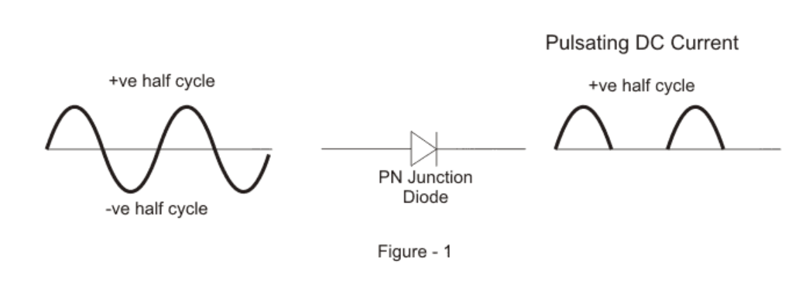 Only one diode is required to construct a half-wave rectifier. In essence, this is all that the half-wave rectifier is doing.

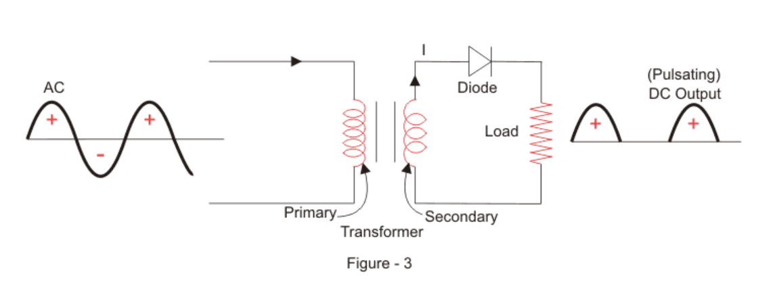

Like the half wave circuit, a full wave rectifier circuit produces an output voltage or current which is purely DC or has some specified DC component. Full wave rectifiers have some fundamental advantages over their half wave rectifier counterparts. The average (DC) output voltage is higher than for half wave, the output of the full wave rectifier has much less ripple than that of the half wave rectifier producing a smoother output waveform. In a **Full Wave Rectifier** circuit two diodes are now used, one for each half of the cycle. A multiple winding transformer is used whose secondary winding is split equally into two halves with a common centre tapped connection, (C). This configuration results in each diode conducting in turn when its anode terminal is positive with respect to the transformer centre point C producing an output during both half-cycles, twice that for the half wave rectifier so it is 100% efficient as shown below.

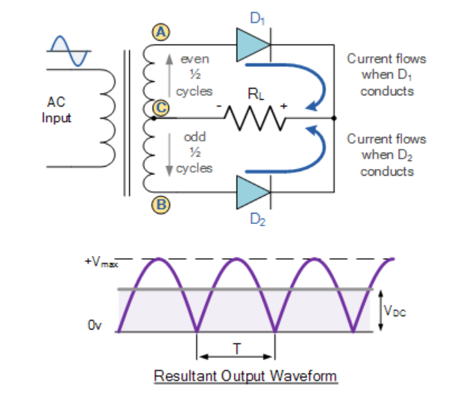

**OBSERVATION:** Half Wave:Circuit a) 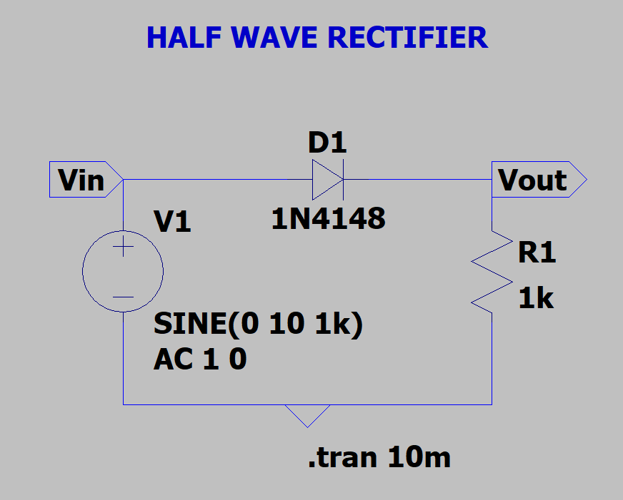

Output a) 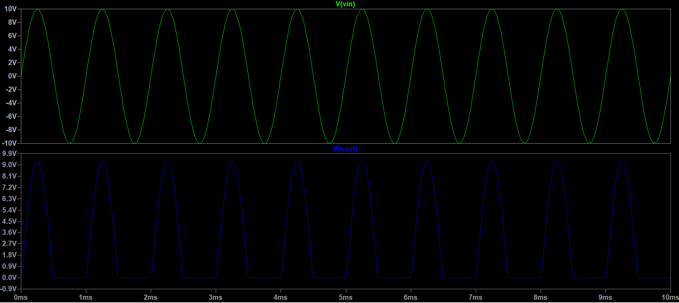

Circuit b) With RC Load: 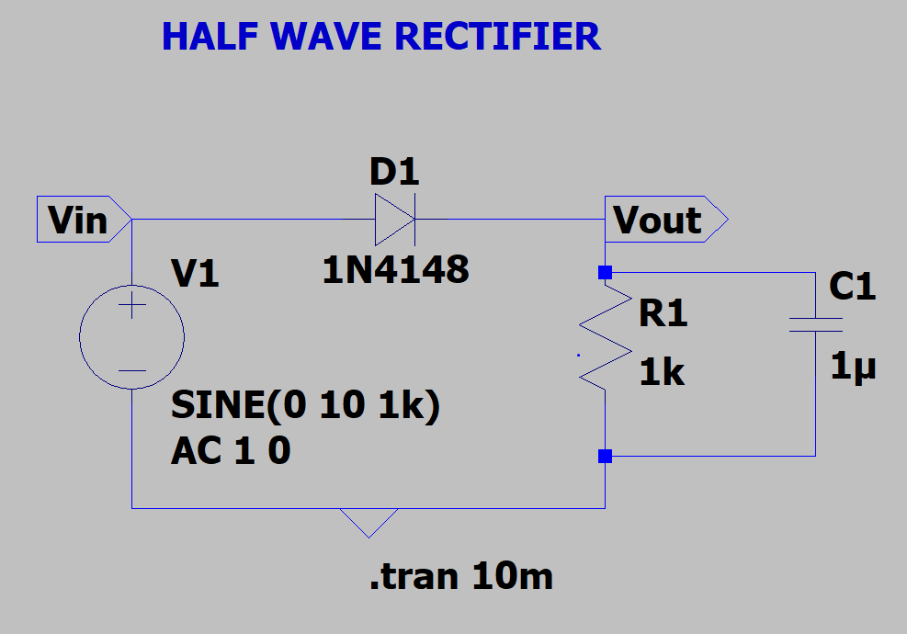

Output b) 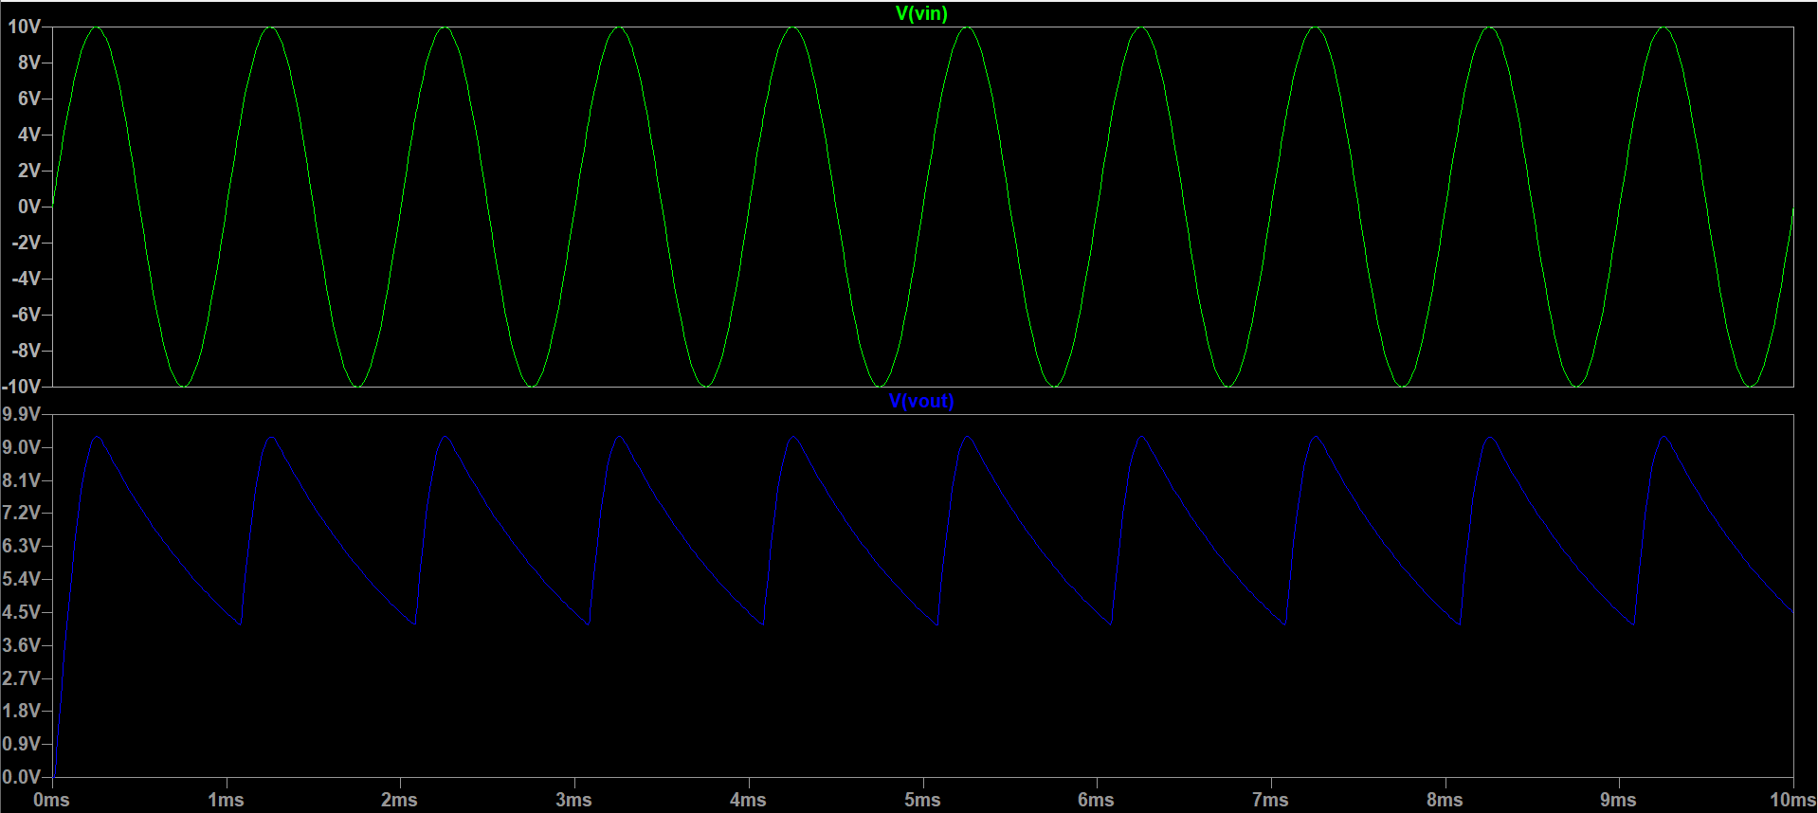

Full Wave:Circuit a) 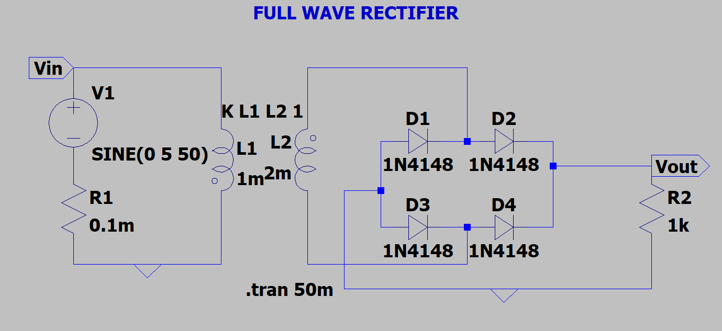

Output a) 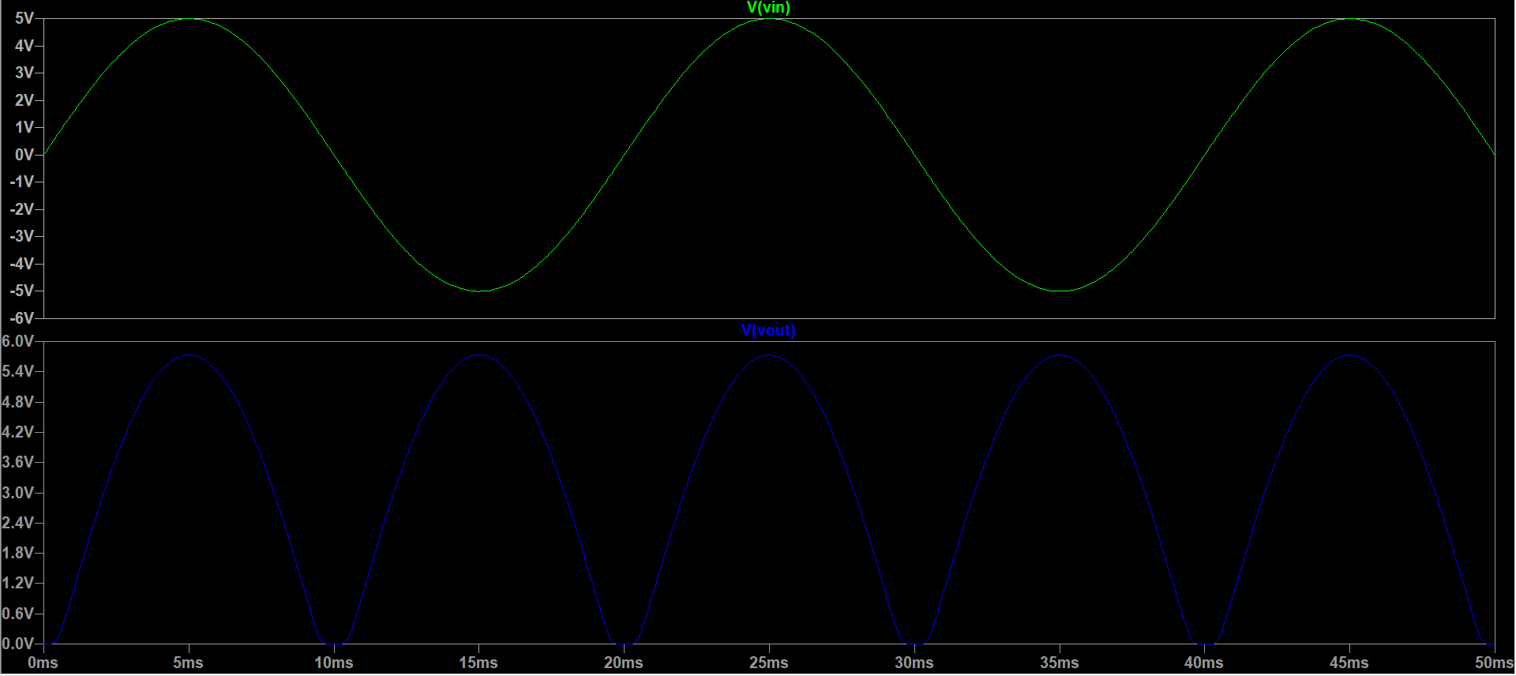

Circuit b)With RC Load: 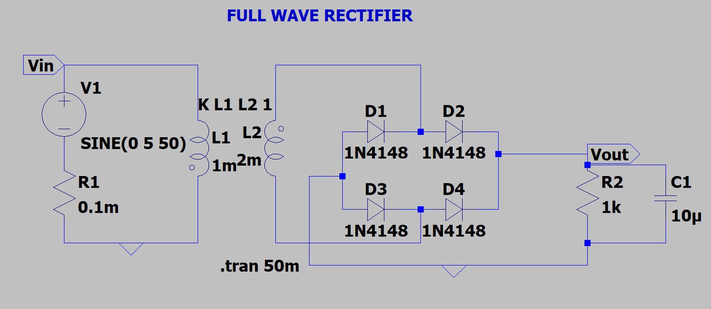

Output b) 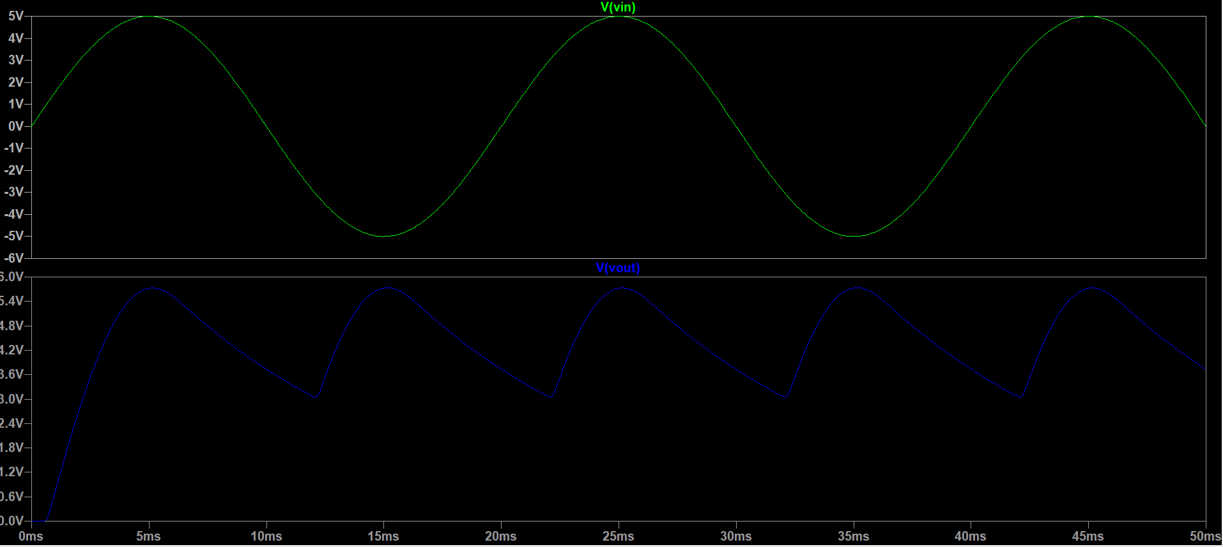

**By:Amogh Garg**

**2020UCO1688**

**COE(Section-3)**